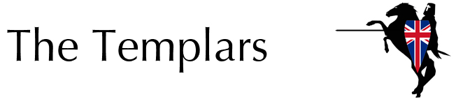

We stand for Independence
We believe in national sovereignty and identity, and the withdrawal of Britain from the EU.
We will make sure that Britain is governed democratically by the elected party in Westminster. And we will stamp out ridiculous politically correct indoctrination in all its guises.
We stand for Control
We believe large-scale reforms are essential to control the current asylum and immigration crisis.
We will raise acceptance standards for immigration, cut support for failed asylum seekers and introduce stricter border controls.
We stand for Law and Order
We believe in restoring faith in the justice system with an end to soft sentencing and red tape.
We will wage war on Britain's drug culture by putting more police on our streets, and aim to restore public order by repealing new drinking laws.
We stand for Public Services
We believe in restoring the services that are for the people, by the people.
Rebuilding the NHS, recruiting more police officers, abolishing experimental teaching methods and ensuring the highest quality equipment to keep our Armed Forces safe.
We stand for our Economy
We believe in a strong independent Britain which will continue to trade with EU countries on our terms.
Our policy to withdraw Britain from the EU will put us in the unique position of having a £12bn surplus to invest back into Britain.

Visit www.thetemplars.e7even.com for more information

